Task 1
import java.io.*;
import java.util.*;

public class Solution {

static long stringSimilarity(String s) {
int n = s.length();
int[] z = new int[n];

int left = 0;
int right = 0;

long sum = n; // whole string has similarity n

for (int i = 1; i < n; i++) {

if (i <= right) {
z[i] = Math.min(right - i + 1, z[i - left]);
}

while (i + z[i] < n &&
s.charAt(z[i]) == s.charAt(i + z[i])) {
z[i]++;
}

if (i + z[i] - 1 > right) {
left = i;
right = i + z[i] - 1;
}

sum += z[i];
}

return sum;
}

public static void main(String[] args) {
Scanner sc = new Scanner(System.in);

int t = sc.nextInt();

while (t-- > 0) {
String s = sc.next();
System.out.println(stringSimilarity(s));
}

sc.close();
}
}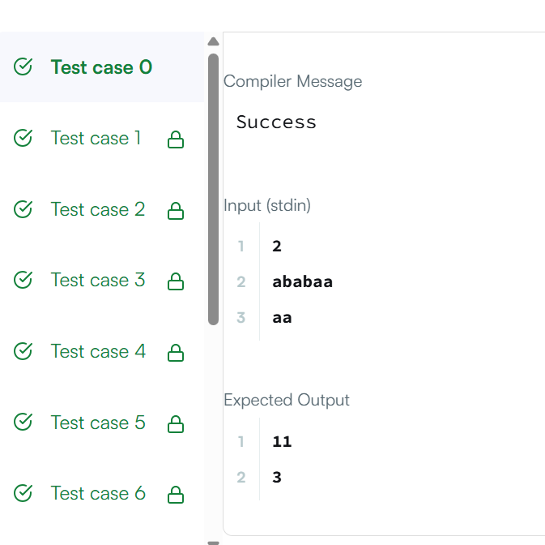
Task 2
class Solution {
public boolean repeatedSubstringPattern(String s) {
int n = s.length();

for (int len = 1; len <= n / 2; len++) {

if (n % len != 0) {
continue;
}

boolean valid = true;

for (int i = len; i < n; i++) {
if (s.charAt(i) != s.charAt(i % len)) {
valid = false;
break;
}
}

if (valid) {
return true;
}
}

return false;
}
}
